**Unit 3 Chemistry Name: ________________**

**2019 Trial exam**

**SECTION A – Multiple-choice questions**

|  |
| --- |
| **Instructions for Section A**  Answer **all** questions.  Choose the response that is **correct** or **best answers** the question.  A correct answer scores 1, an incorrect answer scores 0.  No mark will be given if more than one answer is completed for any question.  Marks will **not** be deducted for incorrect answers. |

**Question 1**



The molecule shown is

**A**. a renewable fuel no matter how it is manufactured.

**B**. a non-renewable fuel as it is always made from crude oil.

**C**. a renewable fuel if obtained from plant matter.

**D**. formed by the action of bacteria in an oxygen free environment.

**Question 2**

Which of the following releases the most energy during complete combustion?

**A**. 0.5 mol of methane

**B**. 12 g of ethanol

**C**. 10 g of octane

**D**. 5 g of hydrogen

**Question 3**

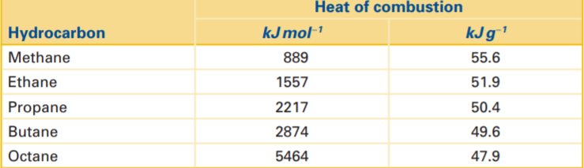

From the table above, it can be concluded that the

**A**. energy density of alkanes increases as the molecules get longer.

**B**. energy density of alkanes drops as the molecules get longer.

**C**. energy density of each alkane is the same.

**D**. energy density increases with the boiling point of the alkane.

**Question 4**

The complete combustion of a propane sample at SLC produces 248 L of CO2.

The mass of propane burnt was, in g,

**A**. 3.33

**B**. 44

**C**. 146

**D**. 440

**Question 5**

The main intermolecular forces present in petrodiesel are

**A**. dipole-to-dipole bonds.

**B**. dispersion forces in most of the molecule with hydrogen bonds on one end.

**C**. dispersion forces.

**D**. weak dispersion forces making diesel a gas at room temperature.

**Question 6**

NO2 gas has many reactions with oxygen. One of the reactions is

2NO2(g) ⇌ NO3- + NO+

In this reaction, the nitrogen atoms are

**A**. oxidised from N3- to N5+

**B**. oxidised to N5+ and reduced to N3+

**C**. reduced from N5+ to N3+

**D**. reduced from N4+ to N3-

**Question 7**

The energy profile diagram for a chemical reaction is shown below.

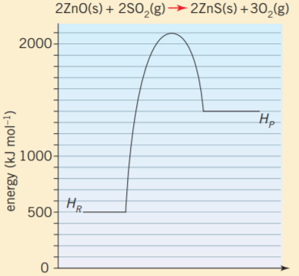

The activation energy, and the value of Δ*H* for this reaction will be, respectively,

**A**. +1600 kJ mol-1 and +900 kJ mol-1

**B**. +1600 kJ mol-1 and -900 kJ mol-1

**C**. +700 kJ mol-1 and +900 kJ mol-1

**D**. +700 kJ mol-1 and -900 kJ mol-1

**Question 8**

A Zn, Zn2+ half-cell is connected to Fe3+/Fe2+ half-cell. In this cell the

**A**. Fe3+ will be reduced at the positive electrode.

**B**. Fe2+ will be oxidised at the negative electrode.

**C**. Zn2+ will reduced at the positive electrode.

**D**. electrons will flow from the iron terminal.

*Questions 9 and 10 refer to the following information*

A model of the commercial aluminium-air cell can be made in the laboratory. A sketch of the cell is provided below.

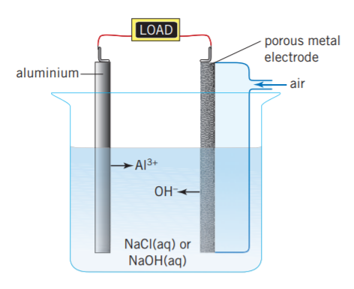

**Cell A Cell B**

**Question 9**

The half equations occurring during discharge in this cell are

|  |  |  |
| --- | --- | --- |
|  | **Anode** | **Cathode** |
| **A.** | O2(g) + 2e + 2H2O(l) 🡪 4OH-(aq) | Al(aq) + 3e 🡪 Al(s) |
| **B.** | Al(s) +3OH-(aq) 🡪 Al(OH)3(aq) + 3e | O2(g) + 4e + 4H+(l) 🡪 2H2O(l) |
| **C.** | Al(s) +3H+(aq) 🡪 AlH3(aq) + 3e | O2(g) + 4e + 4H+(l) 🡪 2H2O(l) |
| **D.** | Al(s) +3OH-(aq) 🡪 Al(OH)3(aq) + 3e | O2(g) + 4e + 2H2O(l) 🡪 4OH-(aq) |

**Question 10**

Electrons will flow in this cell from the

**A**. oxygen electrode to the positive aluminium electrode.

**B**. oxygen electrode to the negative aluminium electrode.

**C**. aluminium to the oxygen electrode as aluminium is the positive electrode.

**D**. aluminium to the oxygen electrode, making the aluminium the negative electrode.

*Questions 11 and 12 refer to the following information*

Hydrogen and iodine gases combine to form HI gas in a reversible reaction

H2(g) + I2(g) ⇌ 2HI(g)

The value of *K* at a particular temperature is found to be 16.

**Question 11**

Equal amounts of hydrogen and iodine gases are added to an empty reactor. At equilibrium, the concentration of hydrogen is determined to be 0.2 M. The concentration of HI at equilibrium will be, in M,

**A**. 0.4

**B**. 0.64

**C**. 0.8

**D**. 4

**Question 12**

The value of *K* at the same temperature for the equation

HI(g) ⇌ ½ H2(g) + ½ I2(g)

will be

**A**. 0.0625

**B**. 0.25

**C**. 0.625

**D**. 4

**Question 13**

A rate-time graph is shown below for a reversible reaction, A(g) + B(g) ⇌C(g).

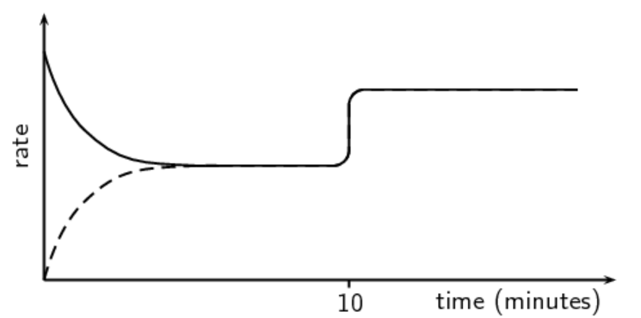

The change occurring at the 10 minute mark could be

**A**. an increase in volume

**B**. a decrease in volume.

**C**. addition of more reactant B.

**D**. an increase in temperature.

**Question 14**

Haemoglobin is a protein in the blood that can form an equilibrium system with oxygen and with carbon monoxide.

Reaction 1: haemoglobin + O2 ⇌ oxyhaemoglobin *K*1

Reaction 2: haemoglobin + CO  ⇌ carboxyhaemoglobin *K*2

When a person is suffering from carbon monoxide poisoning, it is helpful to place an oxygen mask on the patient’s nose and mouth. From a chemical point of view, this is serving to

**A**. increase the value of *K*1, pushing Reaction 1 in the forward direction.

**B**. increase the [O2] concentration, pushing both reactions in the forward direction.

**C**. increase the [O2] concentration, pushing reaction 1 in the forward direction.

**D**. increase the value of *K*1 and to decrease the value of *K*2.

**Question 15**

Inspection of the electrochemical series shows that hydrogen peroxide (H2O2) can react spontaneously with itself to form water and oxygen gas. Hydrogen peroxide can be stored safely for long periods of time however. The best explanation for this apparent contradiction is that the

**A**. half-equations are not listed correctly on the electrochemical series.

**B**. electrochemical series does not provide any indication of reaction rates.

**C**. values on the electrochemical series do not apply at all if the concentrations are not 1 M.

**D**. hydrogen peroxide has an extremely high activation energy.

**Question 16**

The reaction between marble chips and HCl is

CaCO3(s) + 2HCl(aq) 🡪 CaCl2(aq) + CO2(g) + H2O(l)

Which of the following would not be a practical method of monitoring the rate of this reaction?

**A**. Weigh the mass of water produced.

**B**. Sit a pH probe in the flask.

**C**. Attach the flask to a gas syringe.

**D**. Sit the flask on a balance.

**Question 17**

A current of 30 amps running for 10000 secs produces approimately 1 mole of a metal in an electrolysis cell. The molten solution is most likely to be

**A**. Na2O

**B**. K2O

**C**. MgO

**D**. Al2O3

*Use the following information to answer Questions 18 to 20*

Two aqueous solutions are connected in series to a power supply and 10 mole of charge is passed through the circuit.

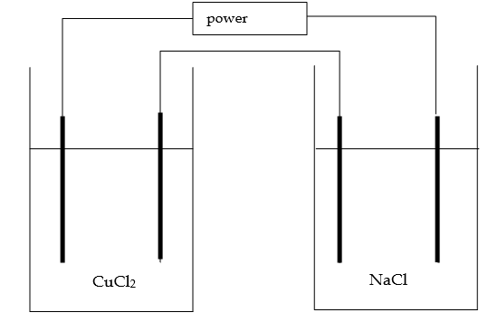 + - -

**Question 18**

The products formed at the electrodes will be

|  |  |  |  |  |
| --- | --- | --- | --- | --- |
|  | Left cell | | Right cell | |
| **A.** | oxygen gas | copper | oxygen gas | hydrogen gas |
| **B.** | copper | oxygen gas | hydrogen gas | oxygen gas |
| **C.** | oxygen gas | hydrogen gas | oxygen gas | hydrogen gas |
| **D.** | chlorine gas | copper | chlorine | sodium |

**Question 19**

The total number of mole of gas produced in this experiment will be, in mole,

**A**. 5

**B**. 7.5

**C**. 10

**D**. 12.5

**Question 20**

If the aqueous solutions were replaced with molten solutions of the same compounds and 10 mole of electrons passed through the circuit, the volume of gas produced would be, in mol,

**A**. 0

**B**. 10

**C**. 12.5

**D**. 20

**Section A 20 marks ____**

**Total Section B 63marks ____**

**Total exam 83 marks ____**

**SECTION B - Short-answer questions**

|  |
| --- |
| **Instructions for Section B**  Questions must be answered in the spaces provided in this book. To obtain full marks for your responses you should   * give simplified answers with an appropriate number of significant figures to all numerical questions; unsimplified answers will not be given full marks. * show all workings in your answers to numerical questions. No credit will be given for an incorrect answer unless it is accompanied by details of the working. * make sure chemical equations are balanced and that the formulas for individual substances include an indication of state; for example, H2(g); NaCl(s) |

**Question 1** (16 marks)

The flowchart below outlines the process of biogas manufacture.

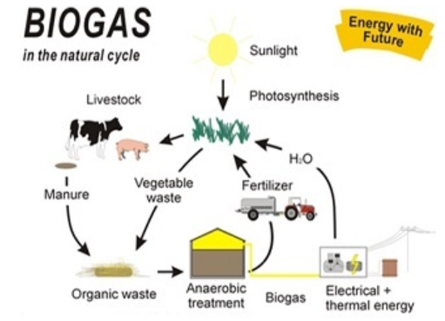

**a. i**. Identify the two sources of organic matter shown in the diagram. 2 marks

____________________________________________________________________

**ii**. List the two main components of biogas and their approximate proportions. 2 marks

_______________________________________________________________________

_______________________________________________________________________

**iii**. Biogas is an example of a renewable fuel. Give a definition of what a renewable fuel

is. 1 mark

____________________________________________________________________

**iv**. Discuss the impact of widespread use of biogas manufacture on total greenhouse gas

emissions. 2 marks

___________________________________________________________________

____________________________________________________________________

**b**. **i**. Write a balanced equation for the complete combustion of methane. 1 mark

____________________________________________________________________

**ii**. Calculate the energy released from the complete combustion of 5600 kg of methane.

1 mark

______________________________________________________________________

**iii**. Calculate the volume of CO2 released by this combustion at 245 0C and 135 kPa.

2 marks

_____________________________________________________________________

_____________________________________________________________________

**c**. An alternative way to generate electrical energy from methane is with the use of a fuel

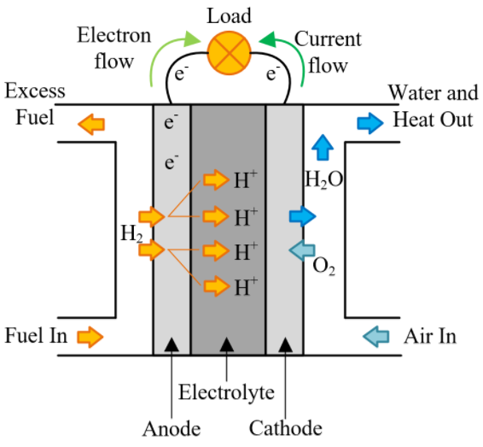 cell like the one shown below.



**i**. Use the template below to write the half-equations and overall equation for the

reaction in this cell. 3 marks

Anode: _______________________________________________________

Cathode: _______________________________________________________

Overall equation: __________________________________________________

**ii**. List two advantages of a methane fuel cell over a biogas generator. 2 marks

_________________________________________________________________

_________________________________________________________________

**Question 2** ( 6 marks)

The diagram below is an example of a Maxwell-Boltzmann distribution.

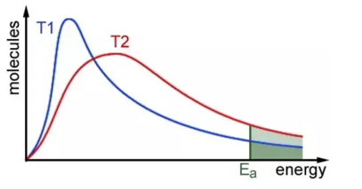

To answer this question, you will be asked to relate this diagram to the reaction between nitrogen gas and hydrogen gas to form ammonia. The equation for this reaction is

N2(g) + 3H2(g) ⇌ 2NH3(g)

**a**. Nitrogen and hydrogen gases are added to Reactor A at 30 0C and to Reactor B at 60 0C.

Refer to the diagram above to explain how the reaction rates in both reactors differ.

2 marks

_____________________________________________________________________

_____________________________________________________________________

______________________________________________________________________

**b**. **i**. Nitrogen and hydrogen gases are added to Reactor A at 30 0C without a catalyst and to

Reactor B at 30 0C with a catalyst.

Refer to the diagram above to explain how the reaction rates in both reactors differ.

2 marks

_____________________________________________________________________

_____________________________________________________________________

______________________________________________________________________

**ii.** The reaction between nitrogen and hydrogen gases is reversible. How will the yield of

ammonia gas formed in the two reactors in part b. compare? Explain your answer.

2 marks

_____________________________________________________________________

_____________________________________________________________________

______________________________________________________________________

**Question 3** (9 marks)

Reactants are added to an empty reactor and the mixture is given time to reach equilibrium. The concentrations of the species in the reactor are monitored and shown on the graph below.

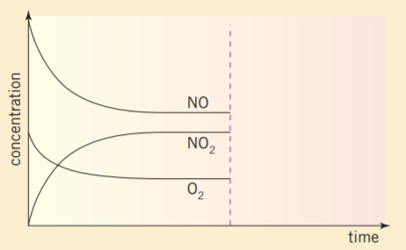

**a. i**. Write a balanced equation for the reaction occurring. 1 mark

_____________________________________________________________________

**ii**. Write an equilibrium expression for the reverse reaction. 1 mark

_____________________________________________________________________

**b**. The reaction occurring is an exothermic one. Suppose the same amounts of reactants

are added to an identical reactor at a higher temperature.

Draw on the graph above how the concentrations of the three gases would differ.

2 marks

**c**. NO2 gas is highly soluble in water. A few drops of water are added to an equilibrium

mixture of the above gases and the system is allowed time to establish a new equilibrium.

Use the template below to indicate how the new equilibrium compares to the previous

equilibrium. 3 marks

|  |  |
| --- | --- |
|  | **New equilibrium compared to previous equilibrium** |
| **Value of *K*** |  |
| **Amount of O2** |  |
| **Amount of NO2** |  |

**d**. The volume of an equilibrium mixture of the three gases is doubled. Explain the impact

of this change on the concentration of O2 gas. 2 marks

_____________________________________________________________________

_____________________________________________________________________

**Question 4** (6 marks)

The cell pictured is an experimental one using lithium and iodine as the two reactants. The electrolyte used is a non-aqueous one.

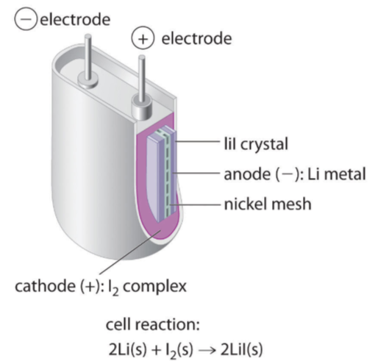

The electrochemical series in your Data Book will be of help in writing equations for this cell.

**a**. Use the template below to show the equations occurring in this cell.

anode: _________________________________________________ 3 marks

cathode: __________________________________________________

overall: __________________________________________________

**b**. What voltage does this cell produce? _____________________ 1 mark

**c**. **i**. Write an equation to explain why lithium batteries rarely use an aqueous environment.

1 mark

______________________________________________________________________

**ii**. Is this cell a fuel cell? Justify your answer. 1 mark

___________________________________________________________________

____________________________________________________________________

**Question 5** (7 marks)

**a.** Draw the biodiesel molecule that could be formed from the reaction betweenlauric acid

and methanol. 2 marks

**b**. Write a balanced half-equation for the conversion of H2S to SO42-. 2 marks

_____________________________________________________________________

**c**. The reaction between ammonia and steam is 3 marks

2NH3(g) + 4H2O(g) ⇌ 2NO2(g) + 7H2(g)

2 mole of ammonia and 2 mole of steam are added to an empty reactor. At equilibrium,

1.6 mole of steam is present.

Calculate the amounts of the other species present.

______________________________________________________________________

_______________________________________________________________________

_______________________________________________________________________

**Question 6** (12 marks)

Magnesium metal is manufactured commercially in an electrolytic cell such as the one shown below.

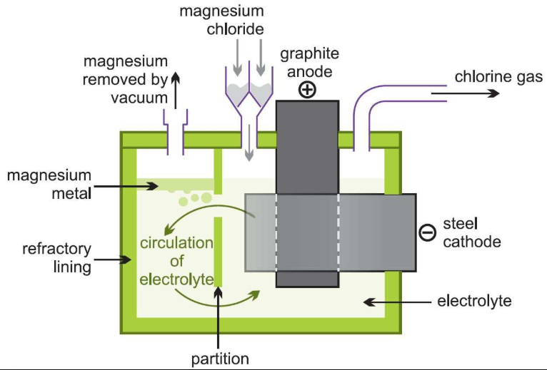

3 marks

**a**. Use your knowledge of electrochemical series, and the information provided on the

diagram to show the half-equations and overall equation for the reactions occurring.

anode: _________________________________________________

cathode: __________________________________________________

overall: __________________________________________________

**b**. A partition is maintained between the two electrodes. Write an equation to explain the

need for the partition. 2 marks

___________________________________________________________________

**c**. A current of 245 amps is maintained in a cell for 6.00 hours.

**i**. Calculate the mass of magnesium obtained. 3 marks

___________________________________________________________________

___________________________________________________________________

___________________________________________________________________

**ii**. Calculate the volume of gas produced at 860 0C and 220 kPa pressure. 2 marks

___________________________________________________________________

___________________________________________________________________

**d**. What would the products be in an electrolytic cell containing a dilute solution of MgCl2

as the electrolyte? 2 marks

___________________________________________________________________

___________________________________________________________________

**Question 7** (8 marks)

A student is investigating the rate of reaction between solid magnesium and HCl solution.

Details of her experiment are outlined below.

**Hypothesis**: The pH of the HCl will rise as the reaction proceeds until it reaches 7.

**Experiment**: 100 mL of 2.0 M HCl is added to a flask and a pH probe is placed in the flask to monitor the pH.

A solid piece of magnesium is weighed and added to the flask.

The pH is recorded every 30 secs until no further reaction is noted.

|  |  |
| --- | --- |
| **Time (min)** | **pH** |
| 0.5 | 1 |
| 1 | 1.2 |
| 1.5 | 1.4 |
| 2 | 1.5 |
| 2.5 | 1.5 |
| 3 | 1.5 |

**Conclusion:** My hypothesis is rejected. pH is not a good measure of the reaction rate.

**a. i.** Write a balanced reaction for the reaction occurring. 1 mark

__________________________________________________________________

**ii**. Explain why the pH of the acid is changing during the reaction. 1 mark

___________________________________________________________________

**b**. For the student’s experiment, identify 3 marks

**i**. the dependent variable _____________________________________

**ii**. the independent variable _____________________________________

**iii.** a controlled variable. _____________________________________

**c.** Discuss the validity of the student’s conclusion. Include in your response an analysis of

the suitability of the experiment design for testing the stated hypothesis. 3 marks

__________________________________________________________________

___________________________________________________________________

___________________________________________________________________

**END OF EXAM**