Unit 3 Chemistry Name: ________________
2020 Trial exam

SECTION A – Multiple-choice questions

Instructions for Section A
Answer all questions.
Choose the response that is correct or best answers the question.
A correct answer scores 1, an incorrect answer scores 0.
No mark will be given if more than one answer is completed for any question.
Marks will not be deducted for incorrect answers.

Question 1
The skeletal structure of a molecule is shown below.

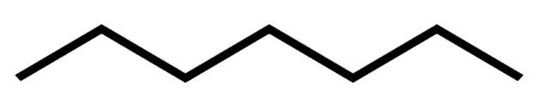

The molecule is most likely
A. to be a significant component of LPG.
B. to be a component of petrol.
C. an example of biodiesel.
D. a typical component of petrodiesel.

Question 2
The density of a sample of petrodiesel is 0.85 g mL⁻¹. The amount of energy released from the complete combustion of 1.0 L of diesel will be, in kJ,
A. 38
B. 1040
C. 38000
D. 45000

Question 3
Which equation is important in the production of a biofuel?
A. C₂H₆(g) + 3.5O₂(g) 2CO₂(g) + 3H₂O(l)
B. C₂H₆(g) + 2.5O₂(g) 2CO(g) + 3H₂O(l)
C. C₆H₁₂O₆(aq) + 6O₂(g) 6CO₂(g) + 6H₂O(aq)
D. C₆H₁₂O₆(aq) 2C₂H₆O(aq) + 2CO₂(g)

Question 4
The complete combustion of 0.025 mol of a fuel produces 0.10 mol of CO₂. The fuel is most likely to be
A. methane.
B. ethane.
C. butane.
D. octane.

Question 5
A 1000 kg coal deposit contains 3.2 g of sulfur. The volume of SO₂ formed from the combustion of this sulfur at 327 ⁰C and 100 kPa is, in litres,
A. 5
B. 10
C. 15
D. 16

Use the following information to answer Questions 6 and 7

A student drops a piece of chalk into a flask containing 200 mL of HCl and records the time taken for the chalk to dissolve completely.

Reaction 1
He then repeats the experiment with two modifications:
Reaction 2 – the chalk is sliced into two along its length.
Reaction 3 – the chalk is cut in two across the middle.

Reaction 2 Reaction 3

Question 6
Collision theory suggests that the time recorded for
A. Reactions2 and 3 will be similar to Reaction 1.as the mass is unchanged.
B. Reactions 2 and 3 will be similar as the surface area is the same in both.
C. Reactions 2 and 3 will be half that of Reaction 1 as the surface area has been doubled.
D. Reaction 2 will be lower than Reaction 3 and both are lower than Reaction 1.

Question 7
Consider the following options to answer this question:
I the mass of the flask will drop
II the volume of gas released will increase
III the pH of the acid will drop
When chalk is dropped into acid,
A. I and III only will occur.
B. II and III only will occur.
C. I and II only will occur.
D. all of I, II and III will occur.

Question 8

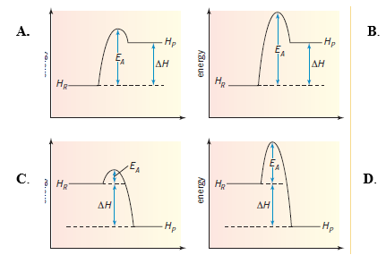

B.

Which alternative represents an endothermic reaction with a high activation energy?
A. Graph A
B. Graph B
C. Graph C
D. Graph D

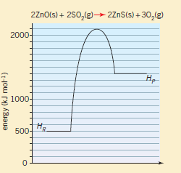
Question 9

The activation energy, and the value of ΔH for the reverse reaction of the one shown will be, respectively,
A. +1600 kJ mol⁻¹ and +900 kJ mol⁻¹
B. +1600 kJ mol⁻¹ and -900 kJ mol⁻¹
C. +700 kJ mol⁻¹ and -900 kJ mol⁻¹
D. -700 kJ mol⁻¹ and +900 kJ mol⁻¹

Use the following information to answer Questions 10 and 11
A galvanic cell is shown below.
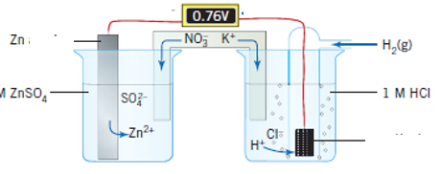

Question 10
In this cell,
A. hydrogen gas will form, electrons will flow to cathode and zinc is oxidised.
B. hydrogen gas will form, electrons will flow to anode and zinc ions are oxidised.
C. hydrogen ions will form, the zinc electrode is coated and hydrogen gas forms.
D. hydrogen ions will form, electrons will flow to cathode and zinc ions are oxidised.

Question 11
The half equations occurring during discharge in the lithium-iron cell are
 | Anode | Cathode
A. | H₂(g) 2H⁺(aq) + 2e⁻ | Zn²⁺(aq) + 2e⁻ Zn(s)
B. | 2H⁺(aq) + 2e⁻ H₂(g) | Zn(s) Zn²⁺(aq) + 2e⁻
C. | Zn(s) + 2e⁻ Zn²⁺(aq) | 2H⁺(aq) 2e⁻ + H₂(g)
D. | Zn(s) Zn²⁺(aq) + 2e⁻ | 2H⁺(aq) + 2e⁻ H₂(g)

Question 12
A sketch of a commercial cell is shown below.
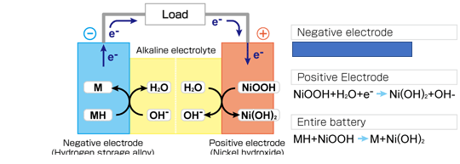
The missing half-equation in this cell is
A. MH + OH⁻ M + H₂O + e⁻
B. MH M + H⁺ + e⁻
C. MH + OH⁻ MOOH + H⁺ + e⁻
D. MH + OH⁻ + H₂O + e⁻ M

Question 13
CH₄(g) + 8OH⁻(aq) CO₂(g) + 6H₂O(l) + 8e⁻
The equation above is
A. an overall equation for the complete combustion of methane.
B. a half-equation for the oxidation of methane in an alkaline fuel cell.
C. a half-equation for the oxidation of methane in an acidic fuel cell.
D. a half-equation for the reduction of methane in an alkaline fuel cell.

Use the following information to answer Questions 14 and 15

The following equilibrium exists in cobalt solutions:

Co(H₂O)₆²⁺(aq) + 4Cl⁻(aq) ⇌ CoCl₄²⁻(aq) + 6H₂O(l)
pink blue

Both forms of cobalt solution have characteristic colours.

Question 14
If a pink solution is heated, it turns blue in colour. The best explanation of the colour change is that
A. the reaction is endothermic
B. the increase in temperature causes more collisions and more successful collisions.
C. the heat causes water to evaporate, favouring the forward reaction.
D. the reaction is exothermic.

Question 15
Silver nitrate solution, AgNO₃, is added to a warm cobalt solution. A precipitate forms, and the pink colour is favoured. The best explanation of this observation is that
A. the reaction is exothermic.
B. the silver nitrate acts as a catalyst for this reaction.
C. the reverse reaction is favoured to replace Cl⁻ ions that precipitated as AgCl.
D. the reverse reaction is favoured to oppose the dilution of the system by the AgNO₃.

Question 16
The equation for the decomposition of phosphorous pentachloride, PCl₅, is

PCl₅(g) ⇌ PCl₃(g) + Cl₂(g) K = 1.4 × 10⁻⁶ M at 30⁰C.

A sample of PCl₅ is added to an empty reactor at 30⁰C. When equilibrium is reached, the
A. [Cl₂] will be greater than [PCl₅]
B. [Cl₂] will be equal to [PCl₅]
C. [PCl₅] will be equal to [PCl₃]
D. [Cl₂] will be much less than [PCl₅]

Question 17
Which of the following aqueous solutions will not produce any metal deposits when electrolysed?
A. Co(NO₃)₂
B. Mn(NO₃)₂
C. AgNO₃
D. Sn(NO₃)₂

Question 18
The current required to deposit 2.43 g of magnesium from MgCl₂(l) in 1 hour will be, in amp,
A. 2.68
B. 5.36
C. 9670
D. 19300

Use the following information to answer Questions 19 and 20
Electrolysis is conducted on an aqueous solution of potassium nitrate, with inert electrodes.
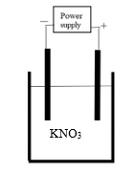

Question 19
In this cell
A. oxygen gas is produced at the negative electrode.
B. potassium metal will be deposited at the negative electrode which is the anode.
C. hydrogen gas will produced at the anode and oxygen gas at the cathode.
D. oxygen gas will be produced at the anode.

Question 20
In this cell, the number of mole of gas produced will be
A. less than the number of mole of electrons flowing through the circuit.
B. equal to the number of mole of electrons flowing through the circuit.
C. double the number of mole of electrons flowing through the circuit.
D. four times the number of mole of electrons flowing through the circuit.

Section A 20 marks ____
Total Section B 60marks ____
Total exam 80 marks ____

SECTION B - Short-answer questions

Instructions for Section B
Questions must be answered in the spaces provided in this book.
To obtain full marks for your responses you should
- give simplified answers with an appropriate number of significant figures to all numerical questions; unsimplified answers will not be given full marks.
- show all workings in your answers to numerical questions. No credit will be given for an incorrect answer unless it is accompanied by details of the working.
- make sure chemical equations are balanced and that the formulas for individual substances include an indication of state; for example, H₂(g); NaCl(s)

Question 1 (9 marks)
Methane is popular fuel. It can be sourced in several differnet ways.
a. Australia has siginificant natural gas deposits. The gas extracted from these is often a
mixture of small alkanes including methane.
i. Natural gas is usually liquified before it is exported. Why is this? 1 mark

______________________________________________________________________

______________________________________________________________________

ii. Explain how methane is separated from natural gas. 2 marks

______________________________________________________________________

______________________________________________________________________

______________________________________________________________________

b. Methane is the main component of coal seam gas. Coal seam gas can be obtained by
fracking.
Explain how fracking works. 2 marks

______________________________________________________________________

______________________________________________________________________

______________________________________________________________________

c. Methane is a major component of biogas, generated from animal or plant waste.
Explain how biogas is formed from waste. 1 mark

_______________________________________________________________________

d. Electricity can be produced through combustion of methane in a gas-fired power station.
i. Write a balanced equation for the complete combustion of methane. 1 mark

______________________________________________________________________

ii. List the energy changes occurring in a gas-fired power station. 1 mark

______________________________________________________________________

iii. Write a balanced quation for the fomation of a pollutant gas in the power station.
1 mark
______________________________________________________________________

Question 2 (7 marks)
The graph below is the starting point for an energy profile diagram.

a. i. Write a thermochemical equation for the complete combustion of ethane. 2 marks

__________________________________________________________________

ii. Use the axis provided to draw an energy profile diagram for this reaction. 2 marks

iii. Calculate the mass of ethane required to heat 1.0 kg of water by 10 ⁰C. Assume
energy transfer is 100 % efficient. 2 marks

______________________________________________________________________

______________________________________________________________________

b. Write a balanced equation for the incomplete combustion of ethane to form carbon
monoxide and water. 1 mark

_____________________________________________________________________
Question 3 (9 marks)
A gas is added to an empty reactor and a reversible reaction occurs. The concentration changes occurring are shown in the graph below.
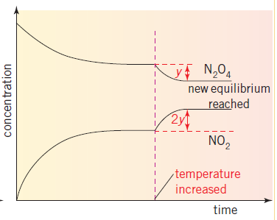
rate

time
a. i. Write a balanced equation for the reaction occurring. 1 mark

______________________________________________________________________

ii. Write an expression for K_{c} for this reaction. 1 mark

______________________________________________________________________

iii. What is the graph illustrating with the use of y and 2y? 1 mark

iv. If NO₂ is brown in colour and N₂O₄ colourless, what will happen to the brown
intensity after t₁? 1 mark

_____________________________________________________________________

b. Is this reaction exothermic or endothermic? Justify your answer. 2 marks

______________________________________________________________________

______________________________________________________________________
c. Use the axes provided to draw the reaction rate graphs for the forward and back
reactions. Include in your graph the time after t₁ while equilibrium is re-established.
3 marks

Question 4 (10 marks)
The picture below comes from a primary school text that shows students how they can construct a simple battery from aluminium foil and activated charcoal.
The diagram on the right provides an outline of what is occurring in this cell.

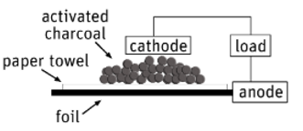
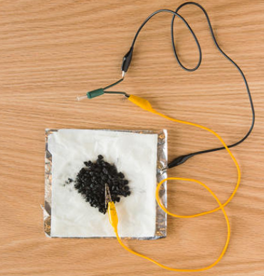

The reactants in this cell are the aluminium metal and oxygen in air. The paper towel is soaked in NaOH, acting as an electrolyte. The graphite does not react, it facilitates the transfer of electrons from the aluminium to the oxygen molecules.

a. Use the template provided to write half-equations and an overall equation for the
reaction occurring. (Both half-equations can be derived from your Data Book) 4 marks

Anode: ________________________________________________

Cathode: ________________________________________________

Overall: ________________________________________________

Approximate cell voltage: __________________________________

b. This cell is a primary cell but its operation can be extended as it is easy to replace
materials consumed. Suggest how this can be done very simply. 2 marks

____________________________________________________________________

____________________________________________________________________

c. The cell below is an example of a fuel cell.
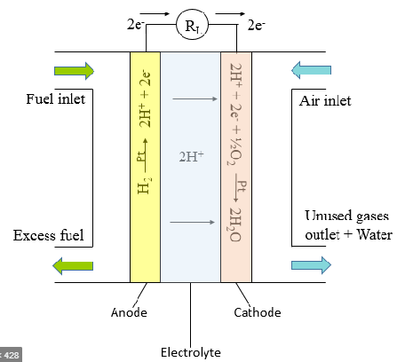

Use the template provided to write half-equations and an overall equation for the reaction
occurring. (Both half-equations can be derived from your Data Book) 4 marks

Anode: ________________________________________________

Cathode: ________________________________________________

Overall: ________________________________________________

Approximate cell voltage: __________________________________

Question 5 (10 marks)
The raw material for a brine cell is a concentrated salt, NaCl, solution. The solution undergoes electrolysis with inert electrodes.
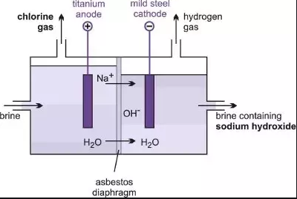

a. Use the template provided, and the annotations on the diagram, to write the half-
equations and overall equation for the reactions in the brine cell. 4 marks

Anode: ____________________________________________________

Cathode: ____________________________________________________

Overall equation: _________________________________________________

Products of this process: ___________________________________________

b. A current of 49.0 amps runs through this cell for 4.00 hours. Calculate the mass of gas
produced at the anode at 560 ⁰C and 200 kPa during this time. 4 marks

______________________________________________________________________

______________________________________________________________________

______________________________________________________________________

______________________________________________________________________

c. i. The product at the cathode would be different if NaCl(l) was used in this cell.
Write a half-equation for this reaction. 1 mark

_____________________________________________________________________

ii. The product at the anode would be different if a dilute NaCl solution was used in
this cell. Write a half-equation for this reaction. 1 mark

_____________________________________________________________________

Question 6 (8 marks)
A sketch of a student experiment used to investigate the rate of a reaction is shown below.

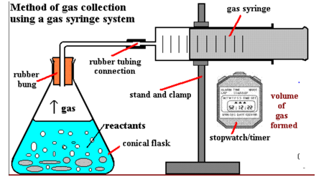

a. Give an example of possible reactants used and the overall equation for the reaction of
these reactants. 2 marks

Reactants: _________________________________

Equation: __________________________________________________________

b. Discuss a possible hypothesis that this setup could be used to investigate and write a
procedure for the experiment that could test this hypothesis. 6 marks

______________________________________________________________________

______________________________________________________________________

______________________________________________________________________

______________________________________________________________________

_____________________________________________________________________
Question 7 (7 marks)
A student sets up a zinc, copper galvanic cell to test the impact on the cell voltage of the electrode separation distance. The circuit the student uses is shown below, where the zinc electrode can be moved to different distances from the salt bridge.
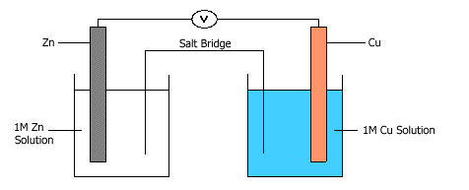

Hypothesis: The voltage in a cell will increase as the electrodes come close together.

Procedure
The student prepares a zinc metal, zinc solution half-cell and connects it in to a copper, copper solution half-cell. The zinc electrode is flexibly placed so that its distance from the salt bridge can be altered. An ammeter and a voltmeter are both added to the circuit.
.
Temperature: 18.4 ⁰C

The voltages obtained and the polarity of each cell are recorded in the table below.
Separation Zn-salt bridge (cm) | Voltage (V) | Current (amps)
10 | 1.2 | 0.64
8 | 1.2 | 0.72
6 | 1.1 | 0.80
4 | 1.1 | 0.88
2 | 1.1 | 0.96

Student conclusion: The electrode separation distance makes little difference to the cell performance.

a. For this experiment, identify 3 marks

i. independent variable _________________________________________

ii. dependent variable _________________________________________

iii. a controlled variable _________________________________________

b. Write an overall equation for the reaction occurring. 1 mark

____________________________________________________________________

c. Discuss the student’s conclusion. Include in your answer the significance of the results
to the manufacturer of such a cell. 3 marks

______________________________________________________________________

______________________________________________________________________

______________________________________________________________________

______________________________________________________________________

END OF EXAM

