Unit 3 Chemistry 2020 Trial Exam Solutions
Section A

1. B: Molecule is heptane. A C₇ is a common component of petrol.

2. C: Mass in 1 litre is 850 g. Data book gives diesel as 45 kJ g⁻¹. Q = 45 x 850 = 38250 density of a sample
of petrodiesel is 0.85 g mL⁻¹.

3. D: Fermentation of glucose to form bioethanol

4. C: ratio of fuel to CO₂ is 1:4 matching the equation for the combustion of butane

5. A: n(S) = 3.2/32 = 0.1 = n(SO₂). V = = 5 L
6. D: Slicing lengthwise will increase the surface area more than slicing across.

7. C: As the reaction proceeds, acid is used up, so the pH rises.

8. B

9: C: Take note that the question asks for the reverse reaction.

10. A: From electrochemical series, H⁺ will react with Zn(s). The zinc is oxidised.

11. D: Zinc is oxidised – this will be at the anode. Hydrogen ions are reduced – at the cathode.

12. A: Add option A to the half-equation on the diagram and it will simplify to the required overall equation.

13. B: The presence of OH⁻ ions indicate an alkaline environment. The presence of electrons shows it is a
half-equation and the loss of electrons is oxidation.

14. A: For an endothermic reaction, K increases as temperature increases. This favours the blue colour.

15. C: The precipitate is AgCl. Its formation lowers the Cl⁻ concentration so the system moves in the reverse
direction, favouring the pink colour.

16. D: This reaction has a very low K value- which can only happen if the amount of products is much lower than the
amount of reactant.

17. B: The only metal more reactive than water is manganese. Refer to electrochemical series in Data Book.

18. B: n(Mg) = 2.43/24.3 = 0.1 mol n(e) = 0.2 Q = 0.2 x 96500 = 19300 C
I = Q/t = 19300/3600 = 5.36 amp
19. D: The products are hydrogen and oxygen. The production of oxygen is oxidation and will occur at the positive
anode.
20. A: The number of mole of hydrogen is half the number of mole of electrons. The number of mole of oxygen is a
quarter. Altogether this is ¾ of the number of mole of electron.

Section B Short answer
Question

Question 1 (9 marks)
a. i. Density of a gas is low- more compact if condensed to a liquid 1 mark
ii. Fractional distillation. Natural gas heated, added to a column. The hot gas rises until each component
condenses at different levels of the tower. Propane and ethane will condense before methane.

b. Natrual gas is absorbed on the surface of the coal. A well is drilled into the coal and water, sand or gas is used to
shake it free. 2 marks

c. Waste is added to a digestor containing bacteria. The bacteria operate in anaerobic conditions to produce
methane. 1 mark
d. i. CH₄(g) + 2O₂(g) CO₂(g) + 2H₂O(l) 1 mark
ii. chemical thermal gas thermal steam mechanical electrical 1 mark
iii. S(s) + O₂(g) SO₂(g) 1 mark

Question 2 (7 marks)
a. i. C₂H₆(g) + 3.5O₂(g) 2CO₂(g) + 3H₂O(l) ΔH = -1560 kJ mol⁻¹ 2 marks

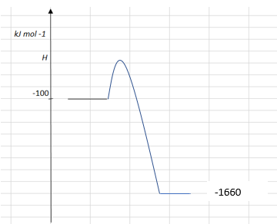
ii. 2 marks

iii. q= 4.18 × 1000 × 10 = 4.18 × 10⁴ J mass = 4.18×10⁴/51900 = 0.81 g 2 marks

b. C₂H₆(g) + 2.5O₂(g) 2CO(g) + 3H₂O(l) 1 mark

Question 3 (9 marks)
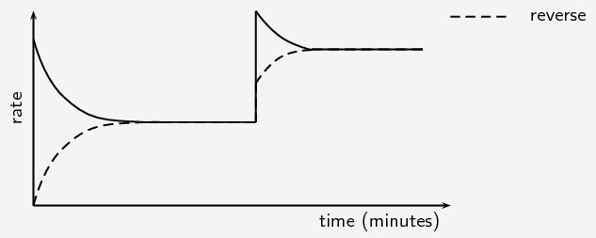
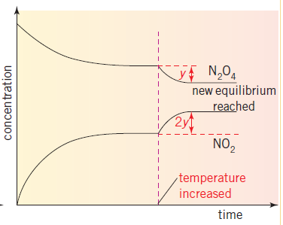
rate

time
a. i. N₂O₄(g) ⇌ 2NO₂(g). 1 mark

ii. K_{c} = 1 mark
iii. The y and 2y reflect the stoichiometry of the equation. The NO₂ will change by twice the N₂O₄.
1 mark
iv. brown intensity will increase with extra NO₂ forming. 1 mark

b. endothermic – an increase in K when the temperature rises is consistent with an endothermic reaction.
2 marks
c. see graph 3 marks

Question 4 (10 marks)
a. Anode: Al(s) + 3OH⁻(aq) Al³⁺(aq) + 3e⁻ 4 marks
Cathode: O₂(g) + 2H₂O(l) + 4e⁻ 4OH⁻(aq)

Overall: 4Al(s) + 3O₂(g) + 6H₂O(l) 4Al(OH)₃(s)

Approximate cell voltage: 0.4 - ⁻ 1.66 = 2.04 V

b. Oxygen is plentiful – replace the aluminium sheet whenever the cell slows 2 marks

c. Anode: H₂(g) + 2e⁻ 2H⁺(aq) + 2e⁻ 4 marks
Cathode: O₂(g) + 4H⁺ (aq) + 4e⁻ 2H₂O(l)

Overall: 2H₂(g) + O₂(g) 2H₂O(l)

Approximate cell voltage: 1.23 V

Question 5 (10 marks)
a. Anode: 2Cl⁻(aq) Cl₂(g) + 2e⁻ 4 marks
Cathode: 2H₂O(l) + 2e⁻ H₂(g) + 2OH⁻(aq)

Overall equation: 2H₂O(l) + 2Cl⁻(aq) Cl₂(g) + H₂(g) + 2OH⁻(aq)
Products of this process: H₂, Cl₂, NaOH

b. Q = It = 49 × 4× 3600 = 7.06 × 10⁶ C
n(e) = /96500 = 7.31 mol
n(Cl₂) = 3.66 mol
V = 127 L 4 marks

c. i. Na⁺(l) + e⁻ Na(l) 1 mark

ii. 2H₂O(l) + 2e⁻ O₂(g) + 4H⁺(aq) + 4e⁻ 1 mark

Question 6 (8 marks)
a. Reactants: Mg/HCl or CaCO₃/HCl 2 marks

Equation: Mg(s) + 2HCl(aq) MgCl₂(aq) + H₂(g)

b. Possible hypothesis: The reaction rate will increase with temperature.
Procedure:
Add 50 mL of 1.0 M HCl to the flask
Heat contents to 20 C.
Add 0.1 g of Mg
Record time taken to produce 50 mL of gas
Repeat procedure with the HCl at 25 ⁰C, then 30, then 35 ⁰C etc
Graph of time taken (y axis) vs temperature. 6 marks

Question 7 (7 marks)
a. i. independent variable separation distance 3 marks
ii. dependent variable current or voltage
iii. a controlled variable temp or soln concentration

b. Zn(s) + Cu²⁺(aq) Zn²⁺(aq) + Cu(s) 1 mark

c. The separation is not affecting the voltage greatly, but it is affecting the current. The manufacturer
should make long, skinny batteries rather than wide ones where the electrodes are a long way apart.
The higher the current the more flexible the cell is in applications it is suitable for. 3 marks

