Unit 3 Chemistry SAC 1: Calorimetry
Comparison and Evaluation task for AOS 1
Scope and sequence
Two experiments to be performed during Week 3 – results recorded in log books.
Week 4: Set of questions relating to the data collected sat under test conditions.
Time for questions: 60 minutes
Data book allowed
Logbook needed to record answers and to show results.
Marking: Marks are totalled from
- a clear record of your measurements
- calculations derived from your measurements
- the assessment questions
Topics covered
- calibration and use of calorimeters
- thermochemical equations and calculations. (Ch 3 Pearson)

PTO

Unit 3: SAC 1 – Calorimetry (comparison and evaluation of data)
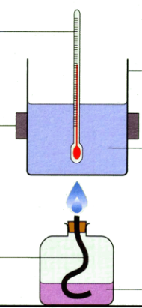
Part A: Heat of combustion of alcohols

Aim: To determine and compare the heats of combustion of alcohols.

Method
Add 100 g of water to a steel can (or 250 mL beaker)
Sit the can on a pipe clay triangle on a tripod or hold the can in a retort stand.
Record the temperature of the water.
Weigh an ethanol burner.
Light the burner and place it under the steel can.
Burn for 5.00 minutes.
Record the temperature.
Record the final mass of the ethanol burner.

Other groups will use different alcohols and data will be shared.

Measurements (record your measurements in your logbook) 3 marks

Part B: Heat of solution of NH₄Cl (comparing calibration methods)
Aim: To determine the heat of solution of NH₄Cl using three different methods.
Method
Add 80 g of water to the calorimeter.
Record the temperature.
Weigh 5 g of NH₄Cl.
Add the NH₄Cl, stir and record the temperature change.

Calibration method 1 – chemical calibration
Replace the 80 g of water and record the temperature.
Weigh 5 g of NaOH solid. (heat of solution of NaOH 44.5 kJ)
Add the NaOH, stir and record the temperature change.

Calibration method 2 – electrical calibration
Replace the 80 g of water and record the temperature.
Add a power supply and ammeter to the circuit.
Add a voltmeter in parallel.
Get the teacher to check your circuit.
Run the current for 4 minutes, recording the temperature every 30 secs.
Measurements 6 marks

Unit 3: SAC 1
Your logbook should show
- your measurements
- your calculations of ΔH.
Part A
1. Write a balanced equation for
a. the complete combustion of propanol. 2 marks
b. the incomplete combustion of ethanol. 2 marks
2. Draw an energy profile diagram on the grid provided for the combustion of ethanol (use the first
row of the table that was on the board). The activation energy is 220 kJ 2 marks

3. a. What conclusion can you draw about the significance of the height of the burner? 2 marks
b. How could you determine the ideal height to place the burner? 2 marks
4. a. Cut out the grid attached and use it to graph the heat of combustion of the three alcohols. 4 marks

b. What conclusion can you draw about the fuels? 3 marks
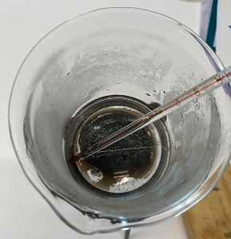
c. Why do they have different ΔH values when they contain the same bond types? 2 marks
5. I took this photo from above one of the beakers after it was used and emptied.
What is the significance of this photo? 2 marks
6. Suppose one group uses the ethanol procedure with 100 g of water but a second group uses the same procedure but 90 g of water. Trace the likely impact of the different mass used and its impact upon the final value of ΔH. 2 marks

7. Why did we not need to record carefully the time each fuel burnt for? 2 marks
Part B
8. The molar heat of solution of ammonium chloride is 14.8 kJ mol⁻¹.
a. How do your values compare? 2 marks
b. What conclusions can you draw about the values? 2 marks
9. Suppose two groups conduct electrical calibration using 100 g of water.
One group then replaces the water before adding 5 g of NH₄Cl while another group adds the 5 g
straight to the calorimeter. Discuss whether this will impact the measurements and results that
follow. 3 marks

10. a. A power supply is found to be producing a voltage that fluctuates during electrical
calibration. What type of error is this? Justify your answer. 2 marks

b. A measuring cylinder used has a scale that reads low values. What type of error is this?
Justify your answer.
2 marks

