Vitamin C content commentary
The usual procedure (Heinemann version for example) of using a titration with iodine solution works well.
However, some notes on the process are –
- the titration can be completed without standardising the iodine solution as long as the iodine solution is made freshly.
- don’t use vitamin C tablets – the ascorbate in them usually prevents an endpoint appearing.
- for pure orange juice, it needs to be diluted about 1:6 to get a reasonable titre. Using a sample of about 40 mL of orange juice also helps pick the endpoint.
- capsicum works well, grind 100 g in a mortar and pestle a bit at a time with water. The water helps make your sample
- this is the colour change occurring
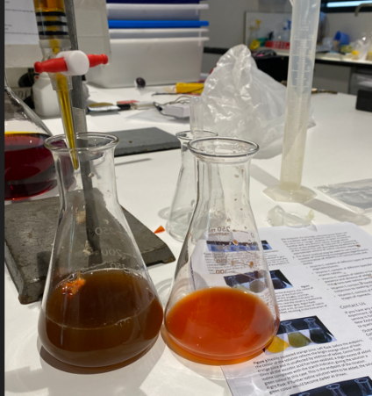
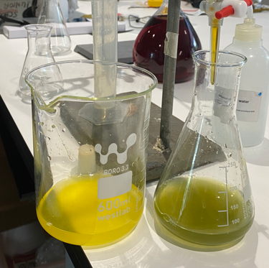

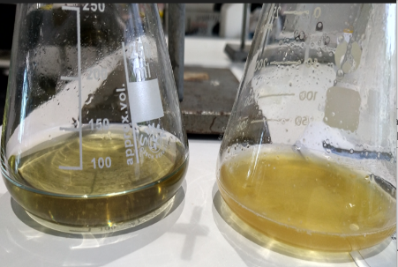

orange juice capsicum (right) Kakadu plum
- Kakadu plums work well but need significant dilution due to the very high vitamin C content.
