Unit 1 Chemistry Experiment: Writing balanced equations

Aim: To develop chemical equation writing skills.

Background

Writing balanced equations to represent or predict chemical reactions is a fundamental skill for chemists. A systematic approach helps with this process. In particular,
- always refer to electrovalency charts before writing formulas.

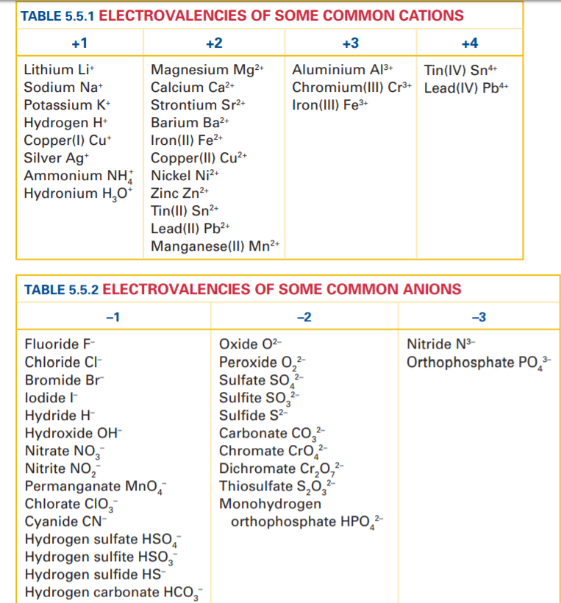

- reaction products can often be predicted by swapping the ions.

Examples
sodium chloride + silver nitrate sodium nitrate + silver chloride
barium hydroxide + magnesium sulfate barium sulfate + magnesium hydroxide

1. Write the products in words to the following reactions (swap the ions as shown above)

copper sulfate + magnesium hydroxide __________________________________

sodium sulfate + barium nitrate _________________________________

Experiment
We will work through a series of reactions, where you will observe the reaction and then write a balanced equation for the reaction. For each reaction, you must follow the process below – do NOT take shortcuts.
Balancing Equations
- Write the equation in words.
- Replace the names with the correct formulas.
- Balance using the coefficients in front of the chemicals.

- Sulfur and oxygen gas
Words
Formulas
Balance

- Magnesium and oxygen gas. Burn a small sample in tongs. Use the Bunsen to start the reaction.
Words
Formulas
Balance

- Silver nitrate and potassium bromide solutions. Add a few mL of each to two test tubes. Pour one test tube into the other
Words
Formulas
Balance

- Aluminium nitrate and sodium carbonate. Add a few mL of each to two test tubes. Pour one test tube into the other
Words
Formulas
Balance

- Light your Bunsen. This is a chemical reaction between methane (CH₄) and oxygen.
Words
Formulas
Balance

