Yr 7 - Intro to Science

Introduction to Science

Scientists

Experimenting

Measurement

Observation

Design

Chemistry

Introduction to Science - Flowchart
Science
(Chemistry)
Scientists – colourful, eccentric, brilliant, doing scary things
Experiment
Ice-cream, candles
Measure
Observe
Heating CuSO₄
Design
(separation)
Equipment
Bunsen, balance
think
safety
particles
Phase changes
elements
Solids, liquids, gases
compounds
Principles: open ended questions, experiment design, measuring, use of everyday materials

Early Scientists

Teacher notes: An investigation of some interesting scientists can set the scene for introducing science. The emphasis is on finding interesting examples.

Q.1 What is science? Give some examples of things that you have done at school or home that might be science.

_______________________________________________________________________

_______________________________________________________________________

2. Can you name a scientist(s)? ___________________________________________

3. What was your scientist responsible for? ____________________________________

_______________________________________________________________________

Examples of Scientists: Balloon flight – how would you like jumping into a crate tied to a large fabric bag with oil burning under the bag?

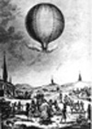
The first balloon flight! Sept. 19, 1783, near Paris.
Passengers – a duck, a rooster and a sheep.
crashed after 15 minutes!

Balloon was made from cloth pieces glued together and powered by lighting a fire in the basket under it

The first manned attempt came about 2 months later on 21st November, with a balloon made by 2 French brothers, Joseph and Etienne Montgolfier. The balloon was launched from the centre of Paris and flew for a period of 20 minutes. The birth of hot air ballooning!!!

Just 2 years later in 1785 a French balloonist, Jean Pierre Blanchard, and his American co pilot, John Jefferies, became the first to fly across the English Channel. They used the very light hydrogen instead of a flame. The balloon was slowly collapsing, so they threw all equipment and all their clothes overboard. The sight of 2 nude Frenchmen dropping into England unannounced!

Unfortunately, this same year Pilatre de Rozier (the world's first balloonist) was killed in his attempt at crossing the channel. His balloon exploded half an hour after takeoff due to the experimental design of using a hydrogen balloon and hot air balloon tied together. His wife was killed several years later when her balloon landed on a house in Paris and toppled onto the ground.

John Dalton
Was one of the first scientists to explain that all things were made from small atoms. His mother, however, was more annoyed that when she sent him to buy her clothes, he always returned with the wrong colour. He was the first to realise that some people are colour blind. Colour-blindness was referred to as Daltonism for many years.
Colour charts
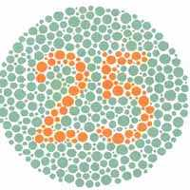
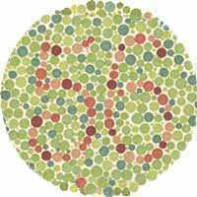

What numbers do you see here? ____________

Dalton, studying atoms and substances, was a chemist.
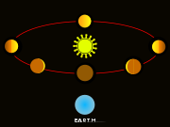
Galilei Galileo – (Astronomer and physicist) Italian scientist was locked in his house for 10 years to stop him telling people that the Earth moved around the Sun and not the reverse. The Bible did not allow for the idea of the Earth circling the sun. (This is the sketch he made)

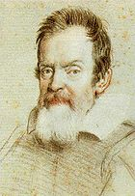
Q.4 If you drop a stone and a grape from a high vantage point at your school, which will hit the ground first?

___________________________________

Q.5 Try it and see if you are right.
What happened when you tried this? ______________________________________

____________________________________________

Q.6 If a stone and a feather are dropped from the same height, what will happen?
______________________________________________

Did you know that on the moon, the feather and stone will fall at the same rate?

Galileo is famous for dropping objects from the Leaning Tower of Pisa to show they fall at the same rate no matter the size.

Robert Hooke – English scientist. One of the first to use a microscope. His microscope is shown here – the object placed on the point and the lens in the metal

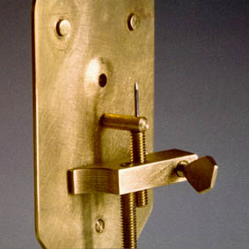
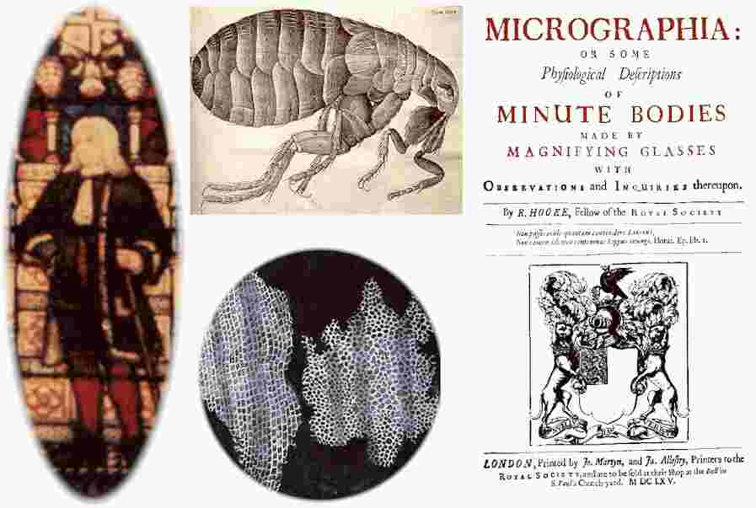

Some of Hooke’s diagrams. This one is a nit, found in student’s hair! Biologists use microscopes.

Antoine Lavoisier – French scientist was the first to identify oxygen gas as the gas that we breathe in. Chemist.
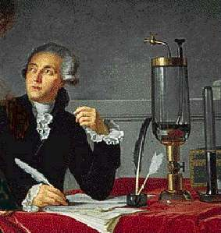
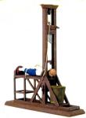
At the age of 35, he was put in jail for no real reason and had his head chopped off in a guillotine. During the French revolution this happened frequently.

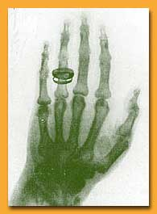

Wilhelm Roentgen – German physicist or radiographer took the first X-ray in 1896. (Of his wife’s hand). Her wedding ring is famous. She died soon after of radiation sickness!

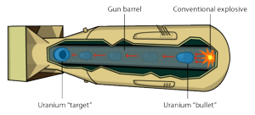
Cross section of the first nuclear bomb – as big as a car and dropped on Hiroshima in 1945. Killed over 80,000 people instantly. Nuclear physics.

Research task
Research a scientist on the internet. Cut and paste anything interesting that you find into a Word document.
Report to the class with a view to making an interesting report.

Possible scientists Newton, Copernicus, Kepler, Cavendish, Edison. Priestley, Watt, Curie, Lister, Pasteur

Homework

Q. 1 Find, and explain, three examples of science in your home.
Science example Explanation
Electric kettle Electricity runs through a wire coil, coil gets hot, heat
transferred to water. Process stops when water boils.

1.

2.

3.

Q.2 One science book quotes ‘glass’ as the most important science invention.
Why might this be?

_________________________________________________________

_________________________________________________________

Q.3 List 4 important inventions.

__________________________________________________________

__________________________________________________________

__________________________________________________________

Q.4 How is science evident in

- Dentistry

______________________________________________________

- Farming

______________________________________________________

- sport?

_______________________________________________________
Experimenting

Making candles
Teacher notes: Students love this as an introduction to experimenting. It leads to a discussion of particles and chemical reactions. Wax from cheap, large candles is melted and poured into a mould. Electrical conduit cut into lengths can be used as a mould, with a test tube stopper blocking the end. See photo below. Plain cotton can be used as wick if no proper wicks can be found.

Aim: To make a candle
To observe the candle burning
To learn how to use science equipment.

Method
Work in pairs.
Collect a mould
Collect a wick. It should be about 2 cm longer than the mould.
Oil the inside of the mould with vegetable oil.

Prepare the wick.
To do this, there is a beaker of molten wax on the teacher’s bench.
Hold your wick by the end in metal tongs.
Dip it in the molten wax on the front bench. You only have to dip the length of the mould.
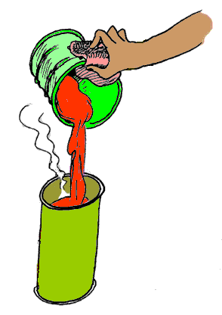
Stretch it out to dry on the waxed paper on the front bench, keeping it as straight as possible.

Weigh about 22 g of wax. Record the mass accurately.
(Do NOT push on the top of the balance. Movement near the balance will cause it to fluctuate more.)
To use the balance: Sit the watchglass on the balance.
Press the T button so the balance reads zero
Add wax until the mass is around 22 g

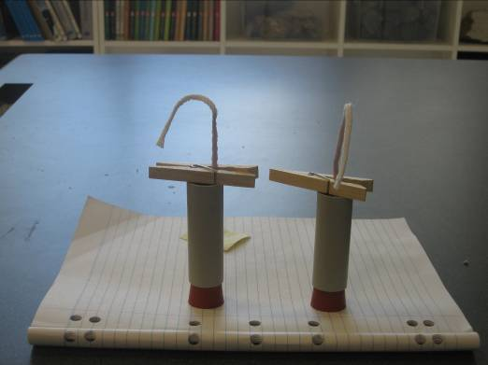
Collect an icy pole stick with a hole drilled through the middle for the wick
Insert your wick through the hole, ready to dip into the mould. Your teacher might help with a piece of wire.

Set up a hot plate.
Add your wax to the beaker supplied and heat it gently
Add a few pieces of crayon to colour your candle.

With your teacher watching, use metal tongs to fill the mould with wax from the can OR your teacher will pour the molten wax.
Leave a small space at the top.
Quickly add your wick, allowing the icy pole tick to sit on top of the mould to hold the wick in place.

Allow to harden over night.
Remove from the mould. This might require rolling the mould on a hot plate.

Weigh your finished candle and record the mass.

Questions
1. What do you call it when a solid turns to a liquid?

2. Do all solids turn to a liquid at the same temperature? Why or why not?

3. What other things have you seen turn from a solid to a liquid?

4. What do you call it when the liquid turns back to a solid?

5. Why grease the mould?

6. How does the mass of the candle compare to the mass of the original wax?

7. What units are used for measuring – temperature?
- mass?

8. Why did we use crayon and not food dye?

Observation
In this section you will burn your candle for 4 minutes.
What do you think will happen to the mass of the candle during this time?

You are also asked to show how observant you are as a scientist by recording your observations of the candle burning. A minimum of 10 observations is expected.

Weigh your candle to recheck its mass. ____________
Light the candle, allowing it to burn for 4 minutes
Write your observations in the box provided.

Reweigh your candle. Has the mass changed?
Candle making - reflection

A
Wax added to beaker
B
Wax now liquid after heating
C
Candle
D
Burning
- You added wax to a beaker to make a candle. Draw the wax pieces in beaker A.
- Write above the letter A, the ‘state’ of the wax.
- In the box below A, sketch how the particles in wax are possibly arranged.
- Above the arrow, from A to B, write in the name of the change occurring as you heat the wax.
- Write above the letter B, the ‘state’ of the wax.
- In the box below B, sketch how the particles in the wax might now be different.
- Above the arrow, from B to C, write in the name of the change occurring as the wax sets.
- Write above the letter C, the ‘state’ of the wax in the candle.
- In the box below C, sketch how the particles in the wax might now be different.
- Write in the box below D, what is happening to the particles when the candle is burning.

To investigate Q. 10 above, light the candle and sit a
beaker on top of it.

Describe what happens to the candle. _____________

What do you see on the inside of the beaker? _______

Explain what you have seen? _____________________________

Can you think of other examples where oxygen is important to burning?

Key Equipment

Balance
The balance you use is a very expensive one. It needs to be handled carefully.
Make a list of things to keep in mind when using the balance.

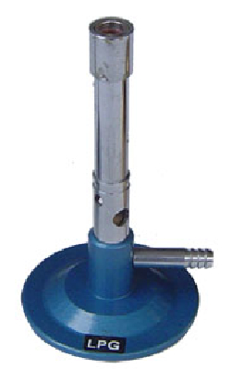
Bunsen

Always use the Bunsen on a mat and wear goggles and lab coat.
Air hole

collar

Examine the Bunsen and the adjustable collar that it has. Close the air hole.

Connect the hose to the gas tap, pushing the hose on at least two notches.
One person only should light the Bunsen. Do this by
- striking a match away from you
- turning on the gas
- holding the lit match about 1 cm above the top of the Bunsen.

Adjust the air hole on the Bunsen and record how the appearance of the flame changes.

Air hole closed, flame is ________________________
Air hole half open, flame is ______________________
Air hole fully open, flame is _____________________

Q. 1 What can you conclude about the effect of the air hole?

_____________________________________________________________

Q. 2 Why do you think this is happening?

_____________________________________________________________

Hold a piece of copper wire in metal tongs and place it in the flame in different positions and at different heights.

Q.3 What conclusions can you draw as to the where the flame is hot or not?
__________________________________________________________________
Taking Measurements

Record all measurements clearly on this sheet, using the correct units.
For each task, write down what quantity you are dealing with and the unit used.

1. Record the temperature in each of the four corners of the room.
(Allow time for the thermometer to adjust to any change, if there is any)
Corner 1 _____________ Corner 2 _____________
Corner 3 _____________ Corner 4 _____________

Conclusion?

Quantity: _____________ Unit: _________________

2. Add some water to a 10 mL measuring cylinder and to a 100 mL measuring
cylinder.
Examine the water level very carefully.
Is it easy to read the volume of the water?

__________________________________________________
Draw what you see at the water surface on the cylinder provided here.
On which measuring cylinder is this problem more significant?

__________________________________________________
How should you go about obtaining consistent results?

__________________________________________________

Quantity: _____________ Unit: _________________

3. Take a beaker and fill it to one of the measurements shown on the side i.e. 40 or
50 mL.
Pour the liquid into a 100 mL measuring cylinder and record the volume.
What do you notice?
_______________________________________________________________
Which do you think is more accurate (beaker or measuring cylinder)? ________

If you want to measure out 4 mL of water accurately, which piece of glassware
should you use? ____________________

Quantity: _____________ Unit: _________________

4. Teacher demo
Your teacher has two measuring cylinders each with 40 mL of water in them.

What will the volume be if you pour one into the other? _____________

Check if this is true.

Your teacher will next add 40 mL of ethanol to 40 mL of water.

What volume is obtained? ____________________

What do you think has happened?

______________________________________________________________

Quantity: _____________ Unit: _________________

5. Your teacher will challenge the class to make an estimate of a time period by
saying ‘Start’, then ‘Stop’ and asking you to guess the time interval. (Your
teacher will time this interval with a stopwatch)

Trial 1 – your guess: _____________ Actual time: _________
Trial 2 – your guess: _____________ Actual time: _________

Quantity: _____________ Unit: _________________

6. Three objects are provided near the balances.
Pick each one up and estimate its mass.

Estimate 1:_________ 2: ______________ 3. _____________

Actual value: _______ ______________ _____________
Weigh each to see how close you were.

Quantity: _____________ Unit: _________________

7. Measure the area of one of the glass windows in the lab.
Record the measurements

Length: __________ Width: _______________

Repeat the measurement but use a different measuring device.

Length: __________ Width: _______________

How do your values compare? __________________________

Which do you think is more accurate? _________________

If the window was broken and you were replacing it, what size piece of glass
would you order? (Why is the answer not the measurements above?)

_____________________________________________________________

Quantity: _____________ Unit: _________________

8. A container of nails is provided for the class.
Your task is to measure the volume of one nail.
How can you do this?

_____________________________________________________

What answer did you get? _______________________________

Quantity: _____________ Unit: _________________

9. Three different cups are provided.
Rank the cups in the order you think their volume will be.

________________________________________________________________

Test your ranking.

Safety Issues

What steps might you take if

- You notice your partner’s lab-coat has caught fire

____________________________________________________________

- You spill acid on your skin

____________________________________________________________

- You touch a very hot flask

____________________________________________________________

- Spill the contents of a flask onto the bench

____________________________________________________________

- You break a beaker

____________________________________________________________

Which disposable cup is best?
Aim: To decide which disposable cup stays hot the longest
To practise measurement in science

Teacher notes: Measuring and graphing data are important skills for science students. This experiment introduces students to the idea of graphing results and to the notion that the shape of the graph is significant.

Method
Your teacher will provide the class with several styles of coffee cups.
Choose 1 cup from those supplied.
Sit the cup on your bench.

Draw a table with two columns to write in the temperature in the cup every 30 seconds. The headings for your table are time in column 1 and temperature in column 2.

Your teacher will add near boiling water to your cup.
Sit a thermometer in your coffee cup and record the temperature after 30 seconds. This reading will be considered time zero. Make this the first entry in your table.

Record the temperature in the cup every 30 seconds and write the values in your table.
Stop recording temperatures after 10 minutes.

Weigh the cup and the water in it.
Use a measuring cylinder to measure the volume of water in the cup.
Reweigh the dry cup.

Results
What was the volume in the cup? _______________
What was the mass of water in the cup? _________________
Calculate the density of the water. density = mass/volume
temp
100 ⁰C
time 10 mins
Draw a graph of your
temperature readings using
a graph like the one shown

Questions
1. How can you tell which cup is working best to keep the drink warm?

______________________________________________________
2. Look at the results of several groups. What conclusion can you
draw?

_______________________________________________________

3. What quantities have you measured in this experiment?

_______________________________________________________

4. For each quantity, give the units that you used.

5. What other things could you test to compare which cup is better?

________________________________________________________

Particle questions

Teacher notes: Students are taught to consider the behaviour of the particles in substances. Students are asked to predict the outcome of each demonstration below. Then they try and explain what the particles must be doing to have caused this behaviour.
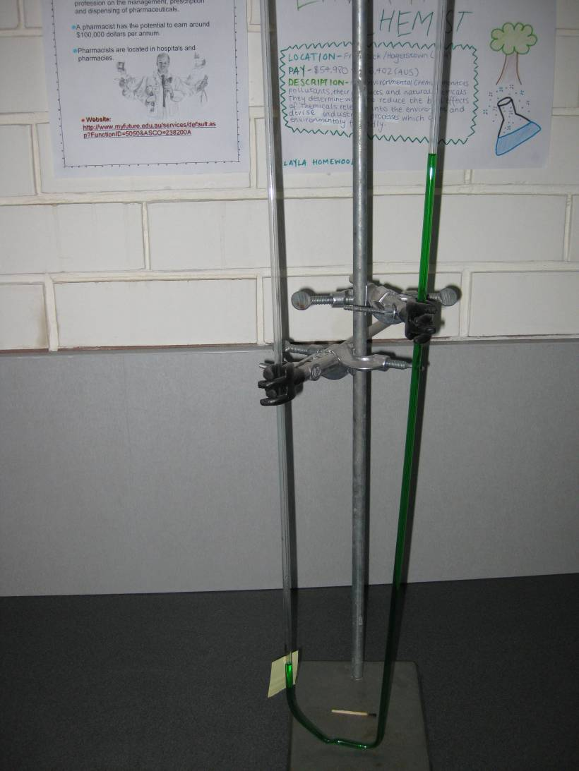
1. What will happen if you heat the sealed section of the tube with a Bunsen?

___________________

___________________

What did happen and why?

___________________

___________________

___________________

Fig. 1. (U-shaped glass tubing with one end
Sealed and air trapped between this end and
The liquid inside)

2. What does the movement of the dye, in Fig.2, tell us about the particles in a liquid?
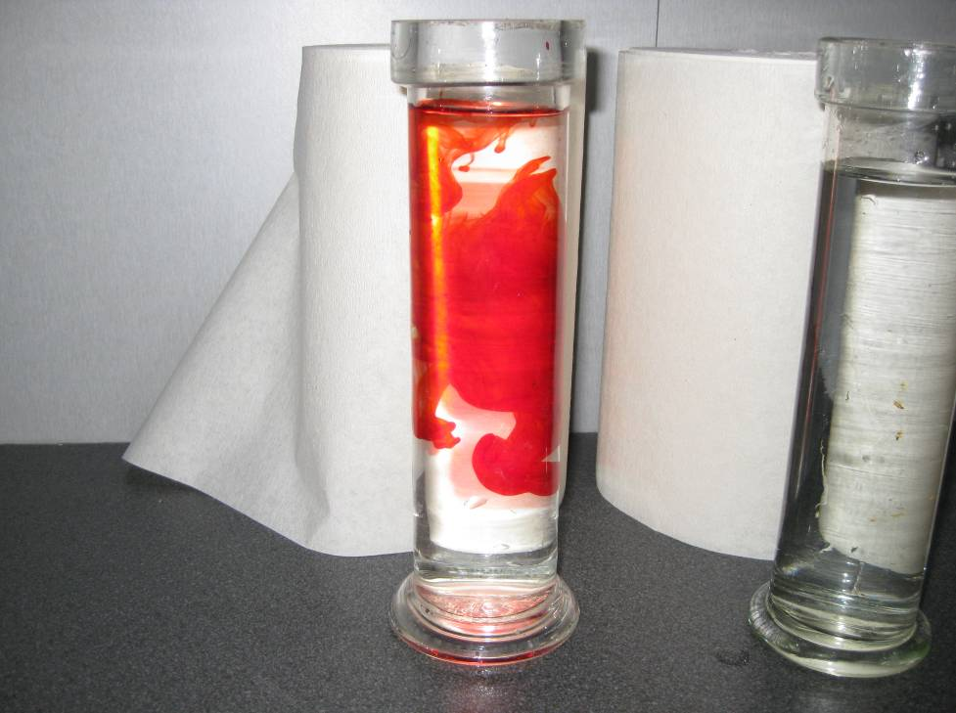
Fig. 2 (food dye added to a gas jar
containing water)

_____________________

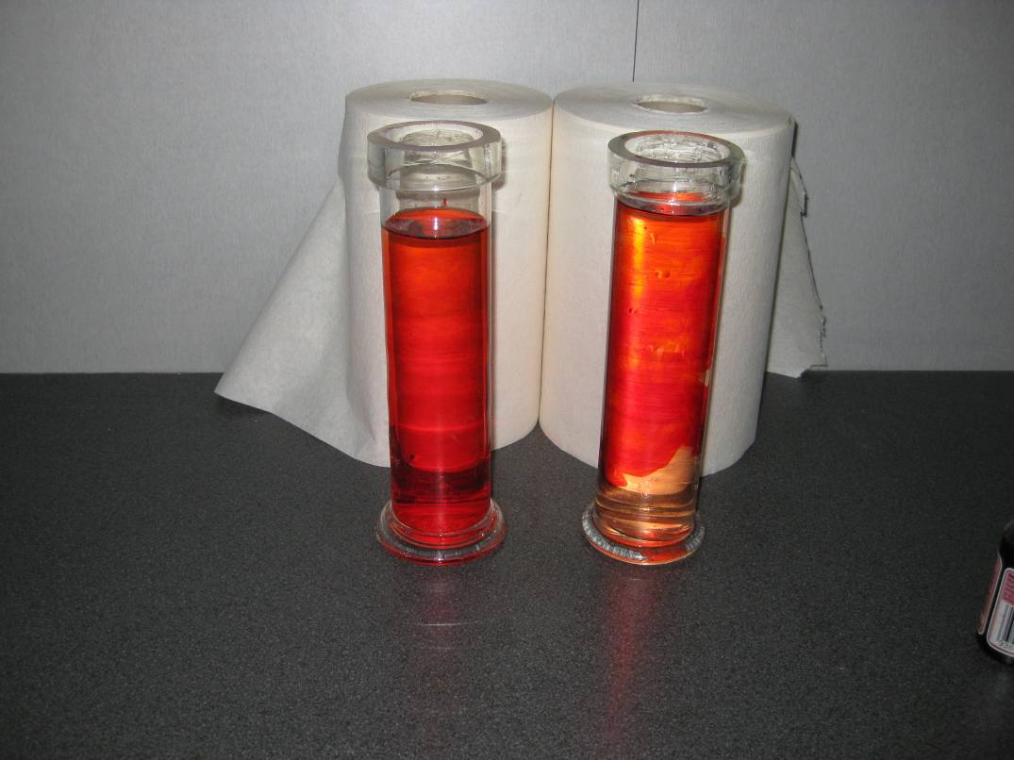

Fig. 3
3.. Why have the two flasks behaved differently?

_____________________

______________________

(one flask containing cold water, the other hot)

Fig. 4 (gas syringe sealed with blu-tack)
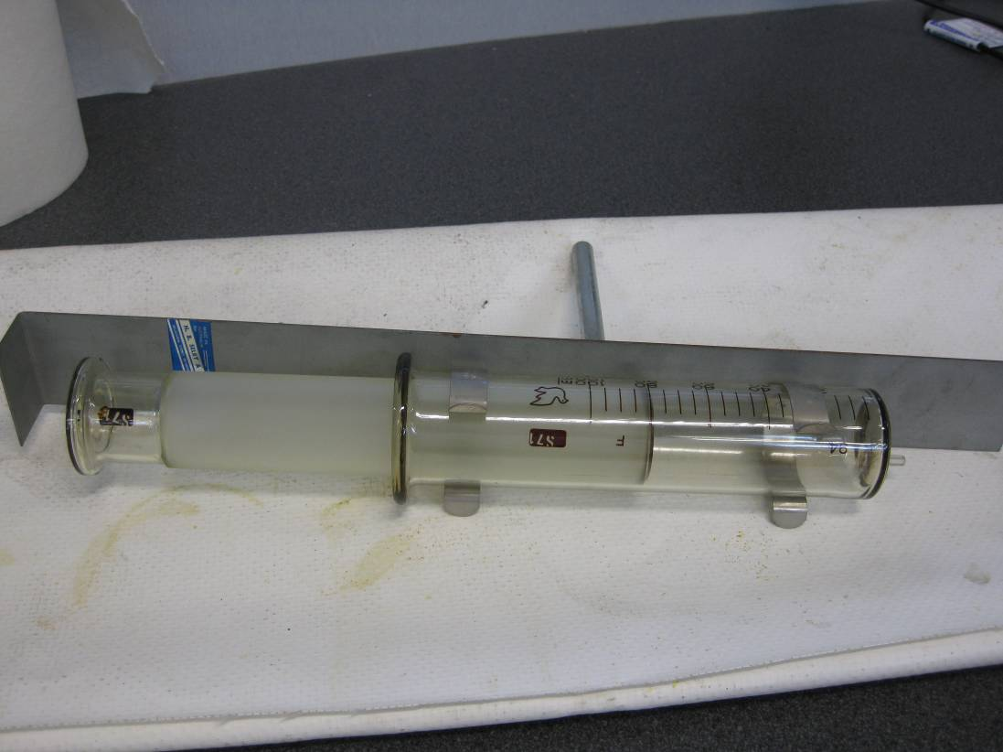
4. If this syringe is filled with gas, what will happen when you push on the handle?

______________________

What does this tell you about the particles in a gas?

______________________

______________________
If this syringe is filled with liquid, what will happen when you push on the handle?

________________________________________________________________________
What does this tell you about the particles in a liquid?

Solids, Liquids and Gases
Which diagram below is an attempt at representing the solid, which the gas and which the liquid? Explain your choices.

Beaker A: _______________________________________________

Beaker B: _______________________________________________

Beaker C: _______________________________________________

A B C

Homework sheet 2

Q.1 Cooks measure many things.
Select a recipe that involves several measurements. Name the item being cooked and
list 5 measurements required.

__________________________________________________________________

__________________________________________________________________

Q.2 Some recipes use metric units and some use older measuring scales.
Give 3 examples of a metric measurement found in a recipe i.e. set oven at 180 ⁰C.

__________________________________________________________________

__________________________________________________________________

Give 3 examples of non metric measurements found in recipes.

__________________________________________________________________

__________________________________________________________________

Q.3 Calculate the area and perimeter of your kitchen table.
Explain how you did this.
__________________________________________________________________

__________________________________________________________________

Q.4 Calculate the volume of one of your saucepans.
Explain how you did this.

__________________________________________________________________

__________________________________________________________________

Q.5 Select 5 items from your house. List the amount and unit the package contains
i.e. milk - 2 litres (volume)

__________________________________________________________________

__________________________________________________________________

__________________________________________________________________

__________________________________________________________________

Q.6 List three examples of activities someone does at your house that involves safety
precautions. State what the hazard is and what safety precaution is taken i.e.
gardening: gloves worn to protect from thorns, prickles and potting mix.

__________________________________________________________________

__________________________________________________________________

Q.7 Cooking involves many safety issues with heat.
List three ways that hot things are a hazard cooking.

__________________________________________________________________

__________________________________________________________________

Q.8 Explain how you might test the following items to compare the quality of different
brands i.e. we tested disposable cups.

- fishing line

__________________________________________________________________

__________________________________________________________________

- the soles of runners
__________________________________________________________________

__________________________________________________________________

- frying pan surfaces

__________________________________________________________________

__________________________________________________________________

Observation

How observant are you? Scientists rely on observations.

Task 1
One third fill the bulb on an ignition tube with the blue substance provided, copper sulfate.

Make sure you have a Bunsen sitting on a protective mat. Do not place hot materials directly onto the bench.

You will be asked to heat the copper sulfate in a flame, observing and recording as many changes as possible.

Observations:
Teacher notes: The copper sulfate crackles and jumps as water leaves the crystals. The water condenses on the ignition tube at first and then can be seen leaving as steam. If some water runs back down the tube it returns to blue.

Light the Bunsen and set it at a mild blue flame.
Hold the ignition tube in metal tongs and pass it in and out of the flame so that it is heated slowly.
Record all changes in the box above.
Finish by heating strongly.
Can you think of how to make the material blue again?

__________________________________________________________________

__________________________________________________________________

What things do you think have happened to the copper sulfate?

__________________________________________________________________

__________________________________________________________________

Do you think it is permanently changed?
__________________________________________________________________

__________________________________________________________________

What was the gas given off? ____________________________________________

Task 2
You are provided with 3 test tubes, each containing a liquid.

Your task is to compare the liquids. Are they all the same? What can you learn about each? Hint: Use all of your senses!
Observations:

Dip a glass stirring rod into each test tube.
What do you notice?

__________________________________________________________________

Teacher notes: Different liquids to use might be water, cooking oil and methylated spirits

Experiment Design
Separation

Aim: To design and test methods of separating a range of mixtures.

Teacher notes: Students have to come up with their own method for each separation task. They are allowed to try their method and are asked to comment on whether it is a good method. A good method will isolate both materials in good condition.

What you need
Sawdust
Copper pieces
Salt
Chalk
Olive oil

Safety
Care is required heating any of the mixtures involved.

Background
There are many examples of society wanting to separate things. The recycle companies needs to separate plastic from paper from metal. Cooks might want to separate egg yolk from egg white. Milk is often separated into cream and skim milk.

Mixtures to separate

1. Sawdust from pieces of copper.
2. Copper pieces from iron filings.
3. Olive oil from water.
4. Salt and chalk.

The best separation is one which preserves BOTH components.

Fill in the Table provided with details of how you propose to separate these mixtures. At this stage, you should not yet attempt the separation.

Mixture | Method proposed
sawdust & copper

copper & iron

olive oil & water

salt & chalk

Collect a sample of each mixture.
Try each of the separations.

Complete the next Table, commenting on the success or otherwise of your proposed method.
Mixture | Method | What happened? | Possible modifications

Did all groups in the class use the same methods?

What principles have you used in your separations? i.e. some items float, others don’t.

What does soluble mean?

Are all powders soluble? (The class could investigate this)

__________________________________________________________________

What is a centrifuge? ( can be used to separate milk to cream and skim milk)

List as many examples as possible of society separating mixtures.

Are all metals magnetic?

What typical items are allowed in recycling bins in your area?

How do you think these items might be separated?

____________________________________________________________________

Substances

Teacher notes: The use of Duplo blocks can make a significant impact on the ability of students to visualize the difference between solids, liquids and gases and between elements and compounds.

Make a list on the board of the substances that you can see in the room i.e. glass.

______________________________________________________________________

How could you classify these substances i.e. heaviest to lightest.

______________________________________________________________________

Look at the image below. Kid’s duplo blocks can be used to represent the particles in substances.
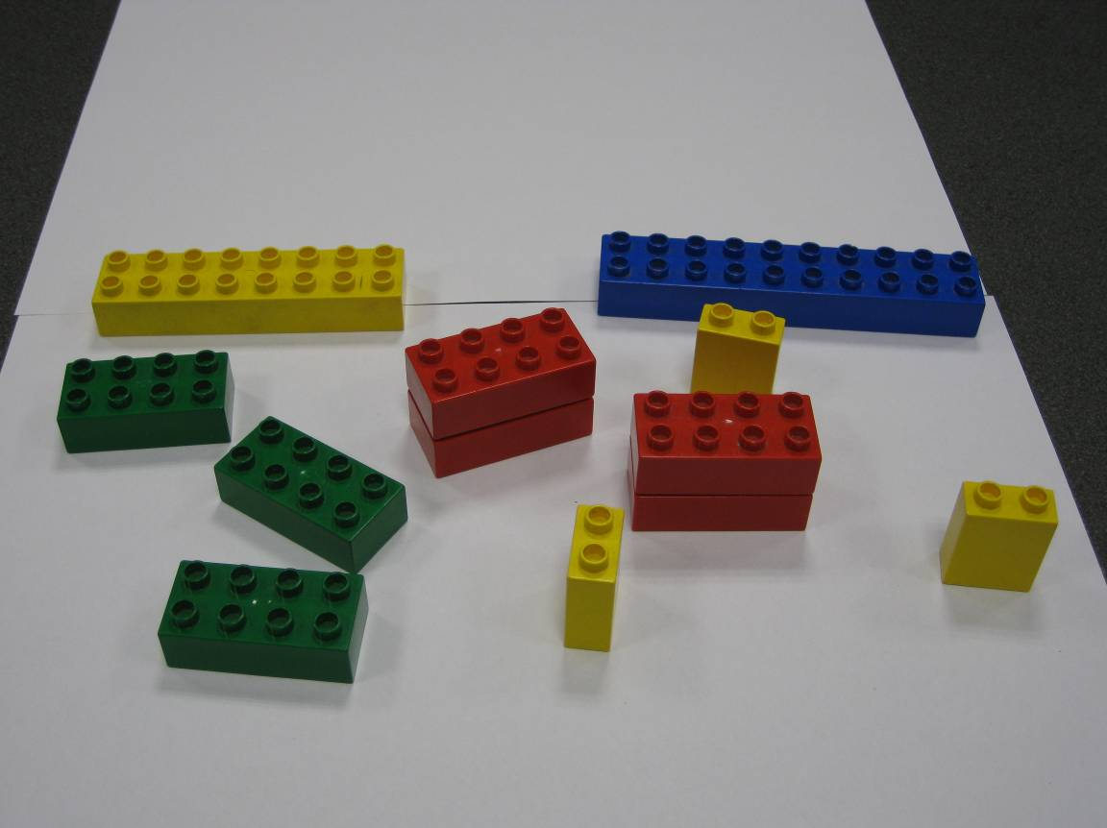

Questions
How many different substances can you see?

__________________________________________________________

How many different types of blocks are there?

__________________________________________________________

How does the red substance (Symbol R) differ from the other substances?

___________________________________________________________

Are all particles the same size?

____________________________________________________________

Are there equal amounts of each substance?

____________________________________________________________

These blocks are like atoms. All substances are constructed from atoms. There are about 92 different types of atom (block). Each type of block is called an element.

How many different elements are in the above photo?

Elements vs compounds
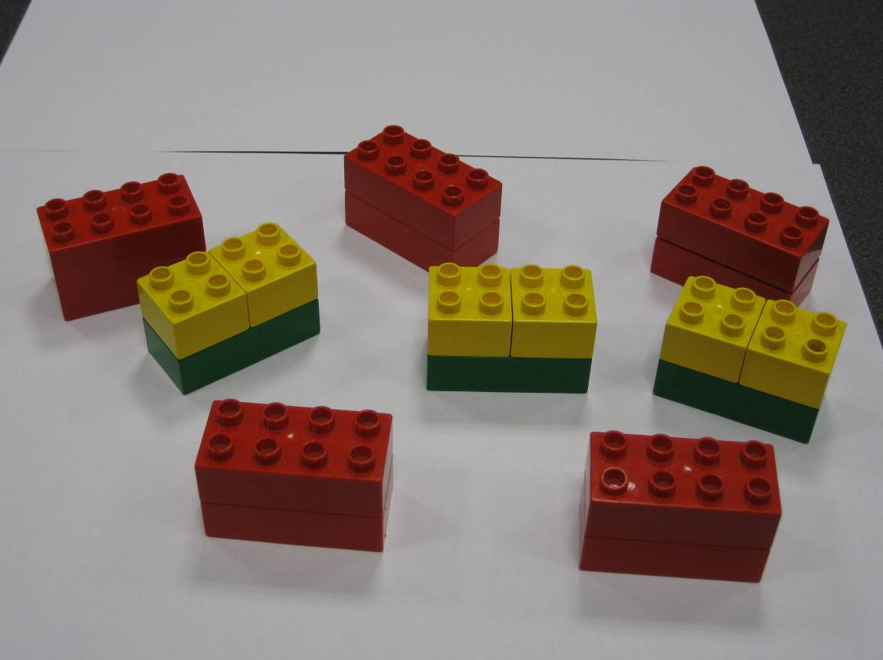
Questions
How many different substances are in this photo? _______________

Are the substances equally abundant? ___________________________

How do the two substances differ?

___________________________________________________________

Write a formula for the red substance using the symbol R (for red) _____

Write a formula for the other substance using the symbols Y and G. _____

One of these substances is a compound and one is an element. What do you think an element is and what a compound is?

_______________________________________________________________

What could a formula be for the compounds below?

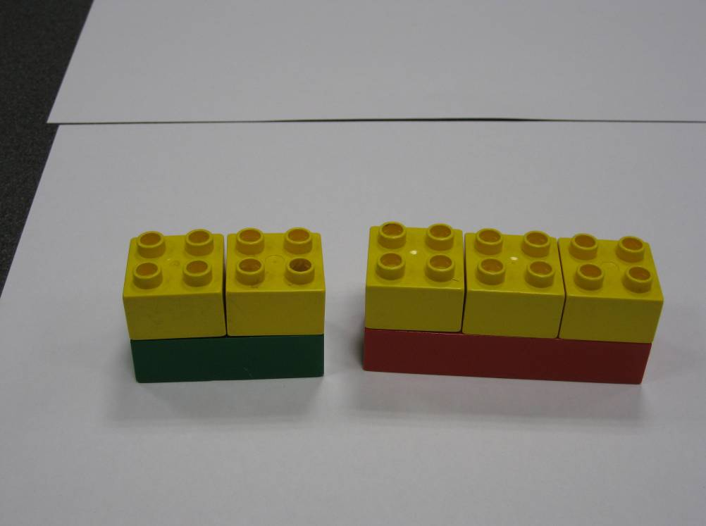

Periodic Table

Rather than duplo blocks, 92 different elements can be found in nature. Some are more common than others i.e. oxygen is a gas present in the air – it is fairly abundant, but krypton is a very scarce gas that we cannot show you a sample of.

The elements are all shown on what is called a Periodic Table. The elements are arranged according to weight (almost).

Post-it Labels: Use yellow post-it labels to identify every element in your room
i.e. frame of desk is steel which is iron, therefore put a label with Fe on it.
Your pencil case might be PVC; if so it contains carbon, hydrogen and chlorine. (C,H,Cl)

Questions
1. Give examples of some elements that you know.

________________________________________________________________

2. Pick 10 elements and learn their symbols off by heart.

________________________________________________________________

3. Gold has been known for a long time. Why do think some elements have been known
for a long time while others have not?

________________________________________________________________

4. Name 3 dangerous elements

________________________________________________________________

5. Name 3 expensive elements.

________________________________________________________________

6. Name 3 safe elements.

________________________________________________________________

7. Name 3 gases

________________________________________________________________

Vocabulary

During this term you have met many new terms. Do you understand the meaning of these terms?
For each term below, explain what it means, use it in a sentence, give examples of like words.

Observation

Measurement

Experiment

Design

Hypothesis

Conclusion

Particle

Units

Temperature

Element

Compound

Soluble

Evaporate

Density

Activity: Homemade ice-cream
Warning: This experiment is edible. Be sure to use clean equipment. Never make food in your science lab.
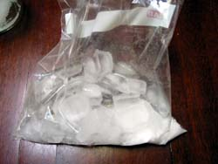
You will need
½ cup whole milk (low fat milk doesn't work as well)
1 tablespoon sugar
flavour for the ice-cream
1 spoon
1 small zip-lock bag
1 larger zip-lock bag
1 tray of ice cubes
6 tablespoons of regular table salt
½ cup of water
What to do
Combine the milk, sugar and flavouring together in the small zip lock bag.
Seal the bag and shake it a few times so that everything is mixed.
In the large zip-lock bag, add the ice cubes, salt and the water.
Put the small bag (check the seal before doing this) into the big bag and seal the big bag.
Gently squish the two bags together for about 5-10 minutes.
As you do this the milk will start to freeze and the ice-cream will form. The longer you agitate the two bags the thicker your ice-cream will be.
.
What's happening?
The salt we add to the ice creates salt water which is actually colder than ordinary iced water. In other words, salt water has to get colder than 0 degrees Celsius (°C) before it will freeze. In this case, milk is like regular water and freezes when surrounded by colder salt water. This allows the ingredients to mix together to make ice cream.
The salt works by lowering the melting or freezing point of water. The effect is termed 'freezing point depression'.
When you add salt to water, you introduce dissolved foreign particles into the water. The freezing point of water becomes lower as more particles are added until the point where the salt stops dissolving. For a solution of table salt (sodium chloride, NaCl) in water, this temperature is -21°C under controlled lab conditions. In the real world, if you were to add salt to a frozen footpath, sodium chloride can melt ice only down to about -9°C.
Since salt interferes with ice crystals forming in water, adding salt to water effectively lowers its freezing point. This is why the oceans don't freeze, even when the temperature is below 0°C. The ocean, which is about 3.5% salt, freezes at approximately -2°C .
For saltwater that's as saturated as it can possibly get (i.e. there's no way to dissolve any more salt in it no matter how hard you tried), the freezing point is -21.1 °C . This is when the saltwater is 23.3% salt (by weight).

Homework: Chemicals in your life
You probably handle more chemicals than you think. This homework sheet takes you through some common household examples.

Q.1 Vanilla essence. If you have some, what is the exact title and where is it made?
What is vanilla for? How is it produced?

_______________________________________________________________

Q.2 Yeast. If you have some, what is the exact title and where is it made?
What is it used for? How do you use it in pizza bases?

_______________________________________________________________

Q.3 Cochineal. If you have some, what is the exact title and where is it made?
What is it used for? Google how it is made – you might be surprised!

_______________________________________________________________

Q.4 Oven cleaner. If you have some, what is the exact title and where is it made?
What is used for? What is the active ingredient? What precautions do you take
when using it?

_______________________________________________________________

Q.5 Methylated spirits. If you have some, what is the exact title and where is it made?
What does your house use it for? Is it drinkable?

_______________________________________________________________

Q.6 Coca Cola. List the ingredients that it contains. See if you can Google the identity of
ingredients just listed as numbers.

_______________________________________________________________

_______________________________________________________________

Q.7 Baking soda. If you have some, what is the exact title and where is it made?
What is it used for? What is its chemical formula?

_______________________________________________________________

Q.8 Salad dressing. If you have some, what is the exact title and where is it made?
Why does it have the ‘murky’ appearance that it does?

_______________________________________________________________

Q.9 Find one other product at home and explain what is in it and why it works.



